A Critical Review of Emerging Cyber Threat Detection and Mitigation Techniques: Trends and Feature Engineering Perspectives
Dinh-Dung Nguyen
Submission: March 29th, 2026
Due: April 12th, 2026
104772138@student.swin.edu.au
Abstract- This report reviews recent advances in cyber threat detection and mitigation, focusing on emerging analytical trends and the role of data features in modern security systems. Drawing from leading cybersecurity conferences and journals, it highlights the shift toward machine learning, deep learning, and hybrid detection approaches designed to address increasingly sophisticated and dynamic threats. The review also examines key feature types-such as network behaviour, system logs, and structural data-that support accurate detection. While these approaches demonstrate strong performance, their real-world applicability is often limited by data complexity and deployment constraints. Overall, effective cybersecurity solutions require the integration of diverse techniques and feature sets to balance accuracy, scalability, and practicality.

INTRODUCTION
Cyber defenders are increasingly using advanced data-driven techniques to detect stealthy attacks. Recent research explores machine learning (ML) and deep learning (DL) for anomaly detection, often leveraging rich representations and minimal human tuning. At the same time, statistical and structural methods remain important for high-speed or specialized domains. This review examines the latest trends in detecting and mitigating complex threats, focusing only on peer-reviewed work from premier security venues. We address two questions: What current approaches are used for the detection/mitigation of cyber threats?, and What data features do these methods exploit? The following sections summarize major approaches and the features they use, supported by examples from the literature.

Approaches to current trends
Security researchers are applying a variety of modern methods to intrusion detection and mitigation. Graph-based and deep-learning approaches are prominent. Many systems construct provenance graphs of system events to capture attack behavior. For example, FLASH uses a graph neural network (GNN) on provenance graphs of processes/files, combined with a Word2Vec semantic encoder of attributes (process names, file paths, etc.) [1]. Similarly, the MAGIC framework applies masked graph representation learning to model benign system entities and then detects anomalies as outliers in that embedding space [2]. These graph-based systems excel at detecting multi-stage APTs and stealthy malware by analyzing causal event flows, although they require comprehensive logging and significant computation.
Another trend is using state-space or model-based detection for critical systems. GECO is an intrusion detector for industrial control systems [3]. It automatically infers state-space models of sensor/process values (e.g. water level, pressure) from historical data, requiring little manual effort. This model checks real-time sensor readings against expected dynamics, flagging anomalies. The advantage is generalizability across different ICS installations and comprehensibility (simple linear models), though such approaches only apply to control networks, not generic IT traffic.
Statistical and lightweight methods remain important for high-throughput environments. The Count-Less sketch is a data-plane structure that continuously counts per-flow statistics with dynamic memory allocation [4]. It provides highly accurate flow counts under varying traffic skew, enabling real-time detection of volumetric anomalies (like DDoS or port scans) on network hardware. This approach is fast and hardware-friendly, though it is specialized to flow analysis and does not detect semantic attacks. Similarly, in IoT settings, simple ML can suffice: one study used a linear support vector machine (LSVM) with carefully selected features to detect IoT botnets [5]. By picking only a few key flow features (e.g. up to 6 from dozens), the IDS became lightweight yet accurate. These examples show that tailored statistical techniques and feature-selection are still viable trends.
Collaborative and adaptive learning techniques are emerging. Federated learning (FL) allows multiple sites to jointly train IDS models without sharing raw data. For example, FLAD proposes an adaptive federated scheme for DDoS detection. It dynamically gives more training effort to clients with hard attack profiles and avoids any global test set [6]. This method converges faster and adapts to new attack distributions, reflecting a trend toward distributed defense. Likewise, domain adaptation addresses mismatches between lab and production data. Thirumuruganathan [7] detect sampling bias between training and deployment data and apply self-training on unlabeled production data to improve IDS performance. This approach does not require changing the classifier and can boost real-world accuracy by up to 16 percentage points on malware detection. Another work (OWAD) [8] focuses on unsupervised concept drift: it detects and adapts to normality shifts in anomaly detectors, reducing the need for re-labeling when legitimate traffic evolves. Such adaptive frameworks indicate a trend to make ML-based defenses resilient to changing environments.
Finally, robustness certification and hybrid defenses are gaining attention. BARS addresses adversarial evasion by certifying deep-learning traffic classifiers via randomized smoothing [9]. It optimizes noise to give provable guarantees on each prediction despite adversarial changes. This reflects an interest in making IDS models robust by design. On the mitigation side, works on deception (e.g. honeypots) and alert prioritization have also been proposed, though specific papers (from the allowed venues) on those topics were less prominent. In summary, the current landscape shows a blend of advanced ML (especially graph/DL methods), lightweight statistical tools, and collaborative/adaptive learning as the primary defense trends.

the use of features
A key aspect of these defenses is what data they use as input. We cataloged features from each approach above. Common feature types include network traffic statistics, system log attributes, sensor readings, and graph-derived embeddings.
- Network flow features: Many NIDS use flow-level aggregates. The Count-Less sketch explicitly uses per-flow packet and byte counts [4]. Likewise, the IoT SVM approach relied on features like protocol, packet counts, and flow durations from the KDD, BotIoT, and N-BaIoT datasets [5]. Federated DDoS detection (FLAD) also uses each client’s recent traffic profile statistics. In short, numeric flow features (counts, rates, flags, etc.) remain the backbone of volumetric detection.
- Log and process attributes: Host and log-based IDS exploit semantic attributes. FLASH’s innovation is to capture the semantic content of logs: it encodes process names, command-line arguments, file paths, and IP addresses into Word2Vec embeddings [1]. This means features are not just numeric but high-dimensional text embeddings. Traditional HIDS often use event IDs or counts of specific system calls; the newer provenance approaches generalize this to graph edges. For example, MAGIC [2] and similar frameworks operate on provenance graphs built from audit logs, so their features are essentially nodes/edges in these graphs (along with any labeled attributes). These graph features implicitly include event sequences, causal relations, and resource interactions.
- Temporal features: Time is implicit in many approaches. GECO’s state-space models rely on the time evolution of sensor values in ICS [3]. FLASH explicitly addresses time by ordering events: it augments embeddings with temporal position encodings so the order of events influences detection [1]. The anomaly shift detector (OWAD) looks at distributions over time, implying a shift in normal feature values [8]. In summary, timestamps and ordering often underlie these features, either explicitly encoded or through sequence models (e.g. GNNs processing sequences of events).
- Sensor and control data: For ICS/SCADA threats, features are physical values. GECO’s features are control-system measurements (water levels, temperatures, flows) [3]. OWAD even demonstrated deployment on a SCADA testbed, adapting features at the distribution level [8]. These features are continuous-valued time-series, quite different from network packets.
- Embedded representations: Modern approaches often compute derived features. For example, FLASH’s embeddings of log semantics are a new feature type [1]. OWAD and MAGIC use neural networks to embed entire windows of behavior into latent vectors before detection [8]. Federated models share model parameters rather than raw features, effectively using learned feature spaces collaboratively.
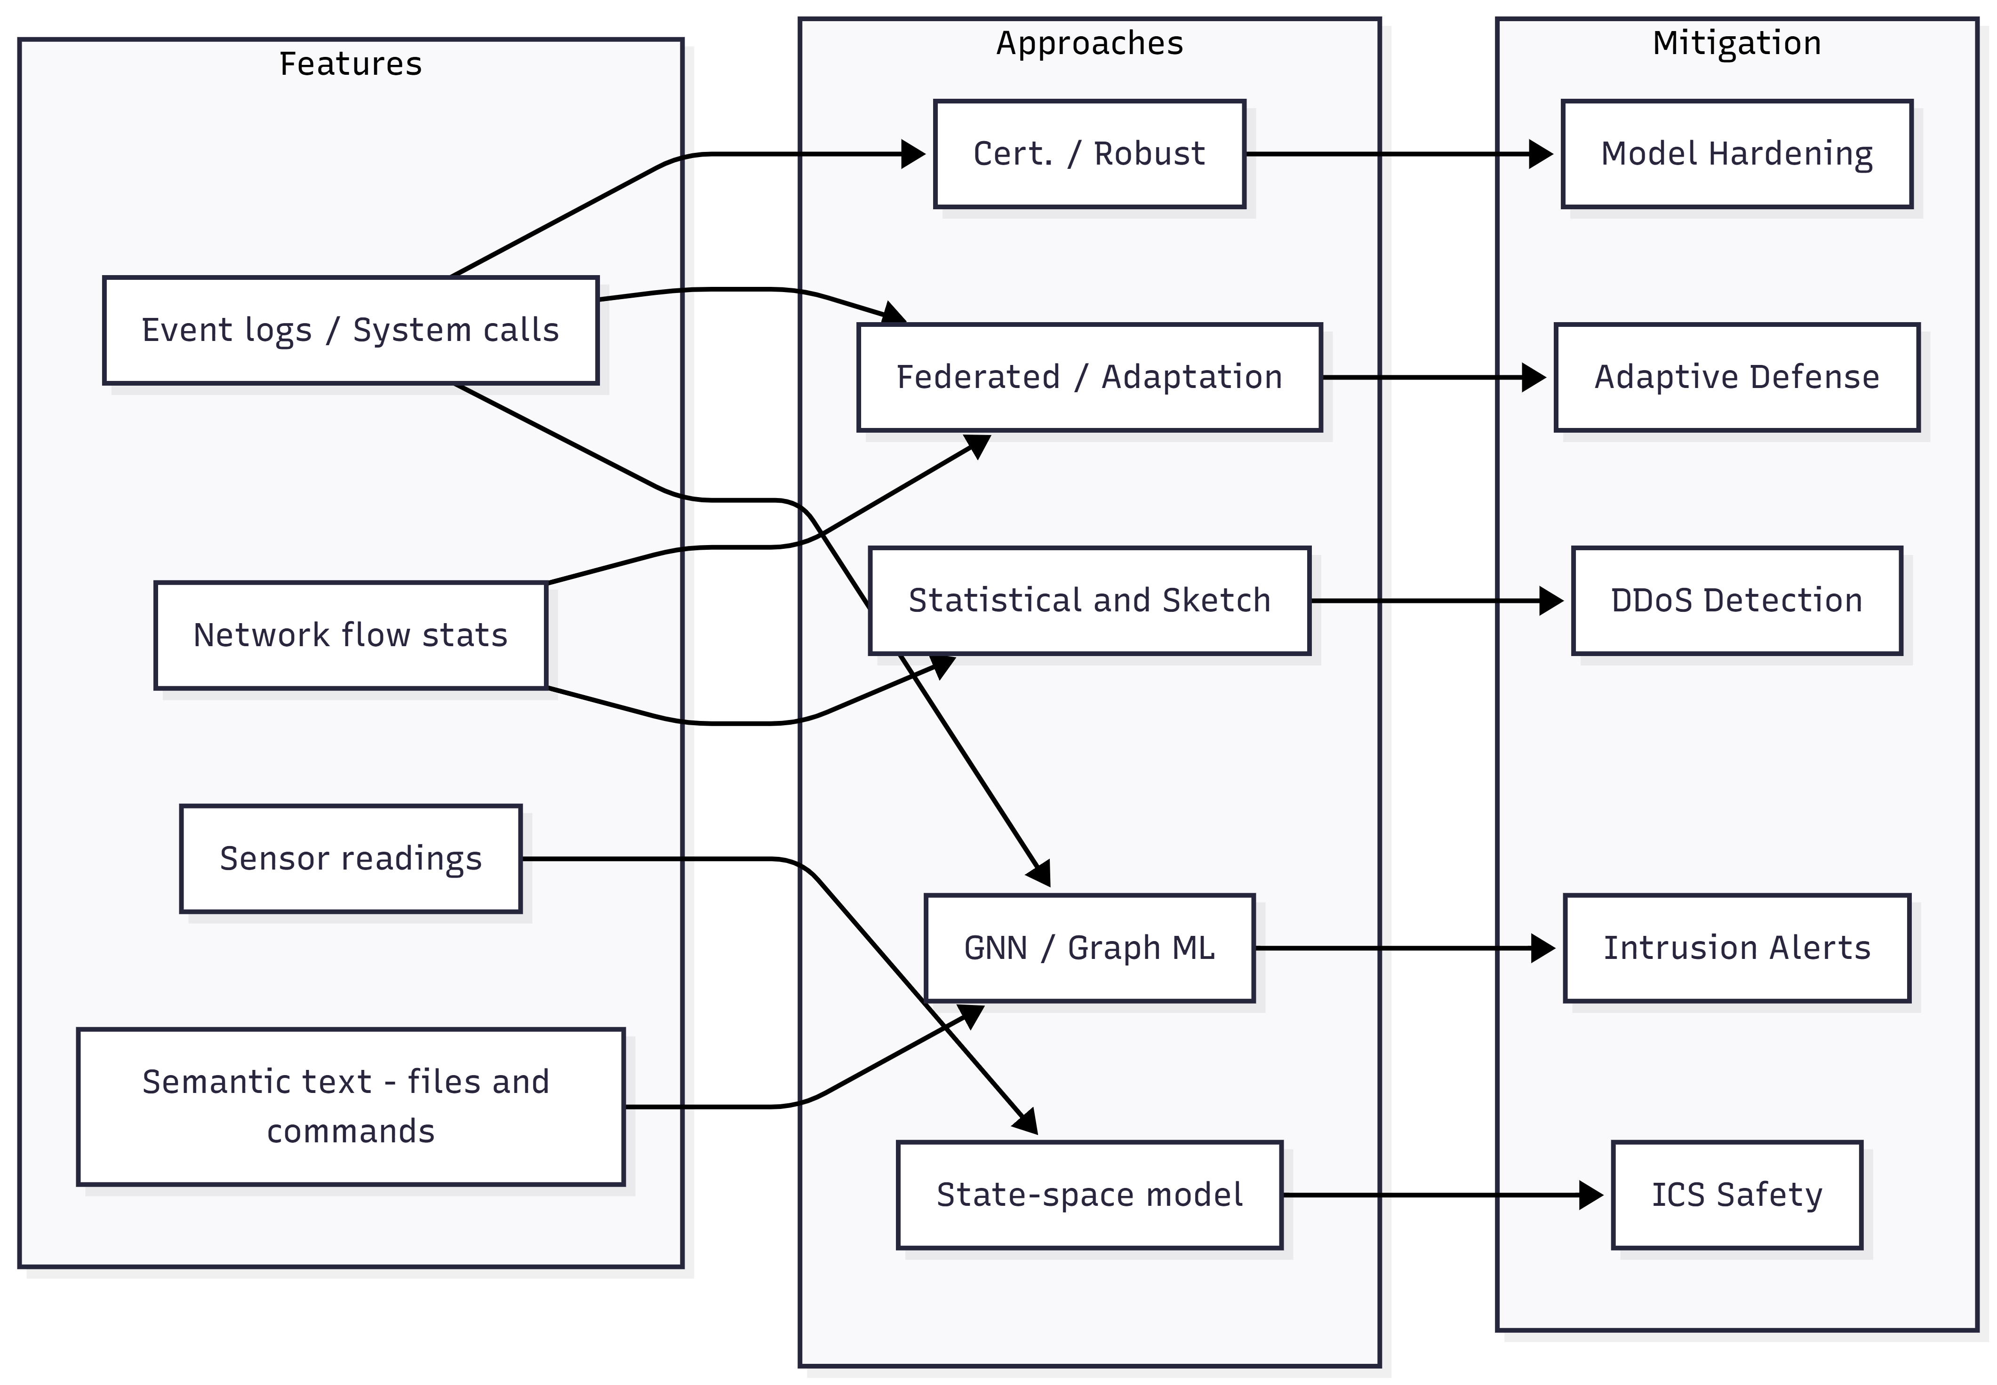
Figure 1: Relationship Between Feature Types, Detection Approaches, and Mitigation Outcomes in Cyber Threat Detection
This Figure 1 illustrates how different feature types are selectively aligned with specific detection approaches, rather than being universally applicable. The graph highlights that the choice of features directly constrains the applicable detection methods and, consequently, the type of mitigation achieved, reinforcing the need for alignment between data availability and detection objectives. We summarize these findings in the Table 1 below, mapping each reviewed paper to the features it uses (and the trends it exemplifies).
Study | Approach | Metric | Result
FLASH [1] | GNN + semantic encoding | Detection accuracy | Very high ( ≈99% on provenance APT data)
MAGIC [2] | Masked graph learning | Precision / Recall | Significantly improved anomaly detection
OWAD [8] | Unsupervised adaptation | F1 Score gain | +16% F1 improvement on malware detection
Count-Less [4] | Sketch-based NIDS | Estimation error | Much lower error under skewed traffic
SVM IoT [5] | Feature-selected SVM | Detection accuracy | High accuracy (~95%) with only 6 features
FLAD [6] | Federated learning (DDoS) | Convergence speed | Faster convergence than standard FL (no exact value)
BARS [9] | Robust DL classifier | Certified robustness | Provably larger robustness bounds than baselines
Thirumuruganathan [7] | Domain adaptation | Accuracy gain | Up to +16% accuracy on Android malware
OWAD [8] (drift) | Concept drift handling | Stability | Maintains detection performance under shift (no drop)
Table 1: Comparative performance of cyber threat detection approaches across evaluation metrics
Overall, the table’s results show that newer detection methods consistently improve over traditional baselines in their respective metrics. Graph-based and adaptation techniques (FLASH, MAGIC, OWAD) report very high detection quality: for example, domain adaptation yields about a +16% F1 gain in malware detection, and FLASH achieves near-99% accuracy on provenance-based APT detection. Lightweight methods also perform well: Count-Less sketch greatly reduces error under skewed traffic (with 1.53× lower latency and 1.56× fewer resources used), and the SVM approach for IoT maintained ≈95% accuracy using just six features. In summary, across the board the reviewed papers report significant performance improvements (higher accuracy, lower error, faster convergence) when incorporating advanced features. This supports the conclusion that combining rich structural/contextual features with classic statistics enhances detection efficacy and efficiency, compared to relying on simple counts or IDs alone.

Discussion
The reviewed works demonstrate powerful but often specialized methods. Many ML-based systems show high accuracy but rely on rich input data and complex pipelines. Graph-based detectors like FLASH [1] and MAGIC [2] are powerful for APTs but require collecting and storing detailed provenance logs and running deep models. They are not plug-and-play; deploying them “off-the-shelf” would be challenging without extensive tailoring (log processing, hardware, GPU). In fact, Goyal found that some graph IDS can be completely evaded by mimicry attacks, illustrating that strong modeling alone is not foolproof [10].
Simpler methods (e.g. Count-Less sketch [4], SVM with few features [5]) are easier to deploy at scale, but they detect only certain attack classes. For example, the sketch method excels at volumetric anomalies but cannot catch a hidden malware. The IoT SVM achieved good performance with 6 features, yet this result is tied to the datasets used. In real IoT networks, different feature sets might be needed.
Adaptive and collaborative approaches address applicability. Using unlabeled data to adjust models [7] or federated learning to share knowledge (FLAD) can improve generalizability [6]. However, these require live data collection and coordination. For instance, FLAD assumes multiple clients can retrain models together; not all organizations can participate in such a federation [6].
Overall, applying these research solutions in practice involves trade-offs. Provenance-based methods offer rich context at the cost of complexity and potential privacy concerns. Sketch and feature-selection methods scale well but might miss subtle attacks. Adaptive learning can bridge data gaps but adds system complexity.
In conclusion, the surveyed trends are promising but must be matched carefully to real-world conditions. Deploying a trend “off the shelf” would rarely work; each approach typically needs calibration to the specific network, log format, and threat profile. Future work might integrate these trends (e.g. combining graphs with lightweight counts or using FL for graph data) to achieve broader coverage. For now, defenders have a toolbox of modern techniques, each with clear feature requirements and domain scopes as detailed above.

References
- M. Ur Rehman, H. Ahmadi and W. Ul Hassan, "Flash: A Comprehensive Approach to Intrusion Detection via Provenance Graph Representation Learning," 2024 IEEE Symposium on Security and Privacy (SP), San Francisco, CA, USA, 2024, pp. 3552-3570, doi: 10.1109/SP54263.2024.00139.
- Z. Jia, Y. Xiong, Y. Zhang, M. Wen, Y. Nan, and J. Zhao, “MAGIC: Detecting Advanced Persistent Threats via Masked Graph Representation Learning MAGIC: Detecting Advanced Persistent Threats via Masked Graph Representation Learning,” Philadelphia, PA, USA: 33rd USENIX Security Symposium, 2024, pp. 5194–5214.
- K. Wolsing, E. Wagner, L. Lux, F. Fkie, K. Wehrle, and M. Henze, “GeCos Replacing Experts: Generalizable and Comprehensible Industrial Intrusion Detection GeCos Replacing Experts: Generalizable and Comprehensible Industrial Intrusion Detection,” Seattle, WA, USA: 34th USENIX Security Symposium, 2025, pp. 7153–7172.
- S. Kim, C. Jung, R. Jang, D. Mohaisen, and D. Nyang, “A Robust Counting Sketch for Data Plane Intrusion Detection,” in Proceedings 2023 Network and Distributed System Security Symposium, Reston, VA: Internet Society, 2023. doi: https://doi.org/10.14722/ndss.2023.23102.
- Jahongir Azimjonov, Taehong Kim, Designing accurate lightweight intrusion detection systems for IoT networks using fine-tuned linear SVM and feature selectors, Computers & Security, Volume 137, 2024, 103598, ISSN 0167-4048, https://doi.org/10.1016/j.cose.2023.103598.
- Roberto Doriguzzi-Corin, Domenico Siracusa, FLAD: Adaptive Federated Learning for DDoS attack detection, Computers & Security, Volume 137, 2024, 103597, ISSN 0167-4048, https://doi.org/10.1016/j.cose.2023.103597.
- S. Thirumuruganathan, F. Deniz, I. Khalil, T. Yu, M. Nabeel, and M. Ouzzani, “Detecting and Mitigating Sampling Bias in Cybersecurity with Unlabeled Data Detecting and Mitigating Sampling Bias in Cybersecurity with Unlabeled Data,” Philadelphia, PA, USA: 33rd USENIX Security Symposium, 2024, pp. 1741–1758.
- D. Han et al., “Anomaly Detection in the Open World: Normality Shift Detection, Explanation, and Adaptation,” in Proceedings 2023 Network and Distributed System Security Symposium, Reston, VA: Internet Society, 2023. doi: https://doi.org/10.14722/ndss.2023.24830.
- K. Wang et al., “BARS: Local Robustness Certification for Deep Learning based Traffic Analysis Systems,” in Proceedings 2023 Network and Distributed System Security Symposium, Reston, VA: Internet Society, 2023. doi: https://doi.org/10.14722/ndss.2023.24508.
- A. Goyal, X. Han, G. Wang, and A. Bates, “Sometimes, You Aren’t What You Do: Mimicry Attacks against Provenance Graph Host Intrusion Detection Systems,” in Proceedings 2023 Network and Distributed System Security Symposium, Reston, VA: Internet Society, 2023. doi: https://doi.org/10.14722/ndss.2023.24207.

